Homework 6: 100 Points
Please submit your answers in a document and upload it in Canvas by the due date.
Present your work neat, clear, organized, logical, and make your case; don’t leave it to our interpretation of your answer. There is 10% penalty per day for delay in submitting the homework.

- Exercise 4.9 a. (20 Points). Hint: Note that in a complex (imaginary) number: a=x+yi; x is a_re, y is a_im. Arithmetic density definition is on Page 308..
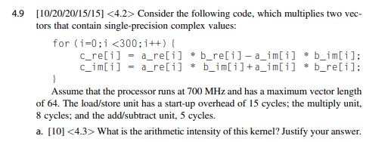
FLOPs Per Iteration: 4 multiply + 2 add/sub = 6
Bytes Per Iteration: (4 loads + 2 stores) × 4 Bytes = 24 Bytes
Arithmetic IntensityI: 6 FLOPs / 24 Bytes = 0.25 FLOP/byte

- Exercise 4.10 (20 Points). Hint: The purpose is to compare a vector processor with a hybrid system of a scalar processor (host) + GPU. Draw a picture to understand it better.
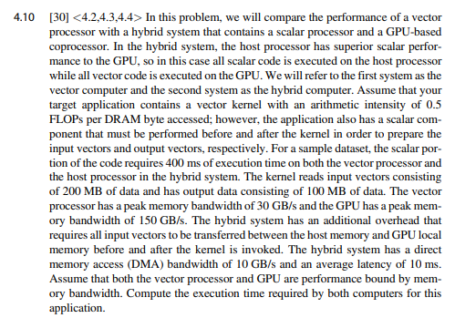
Vector:
Kernel Memory Time= (200 MB + 100 MB)/ 30 GB/s= 0.3 GB/ 30 GB/s= 0.01 s= 10ms
Total= 400 ms + 10 ms= 410 ms

Hybrid:
DMA Transfers= ($\frac{200 MB}{10 GB/s}$ + 10 ms) + ($\frac{100 MB}{10 GB/s}$ + 10ms)= 50 ms
Kernel Memory Time= $\frac{200 MB + 100 MB}{150 GB/s}$= 2 ms
Total= 400 ms + 50 ms + 2 ms= 452 ms
- Exercise 4.13 a,b ( each part 20 points)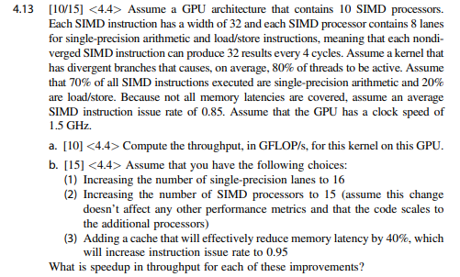
a. FLOP/s= 10 SIMD processors*1.5 GHz * 0.85 instr/cycle *0.7* 0.8 * 8 lanes per SIMD= 57.12 GFLOP/s
b. 1. Speedup= $\frac{10*16*0.85}{10*8*0.85}$= 2x Speedup
2. Speedup= $\frac{16*8*0.85}{10*8*0.85}$= 1.5x Speedup
3. Speedup= $\frac{10*8*0.95}{10*8*0.85}$= 1.117x Speedup

- Exercise 4.16 (20 Points)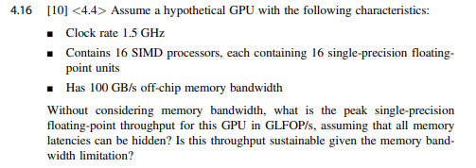
Peak Single-Precision Floating-Point Throughput= 16 SIMDs*16 FPUs/SIMD*1.5 GHz= 384 GFLOP/s
Sustainable: ​$\frac{100 GB/s}{4 B}=\frac{100*10^{9} B/s}{4 B}=25*10^{9}=25 GFLOP/s$
Since 384 GFLOP/s is greater than 25 GFLOP/s, the throughput is not sustainable given the memory band-width limitation.

